Table of Contents
- Nielsen’s Heuristics
- Persona Walkthrough

- Nielsen’s Heuristics

User Control and Freedom
My interface uses this heuristic all through any decision area. I add a clear back out option so then at any point, they can choose to back out as they please. Furthermore, these backout options, have no extended process nor are complex, they simply are labeled either “return” or “back” and upon being clicked, allow the user to return to their previous state without any worry.
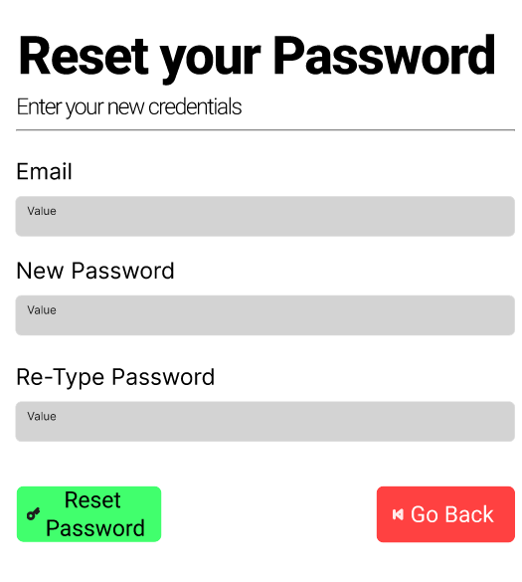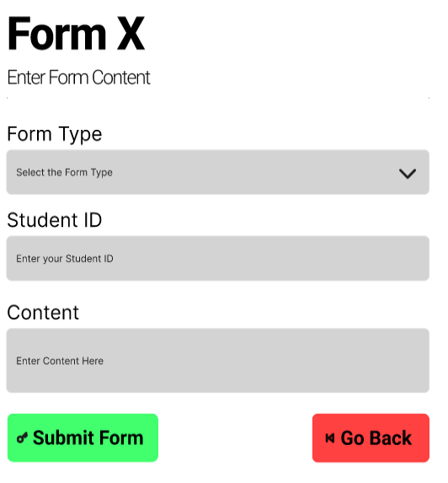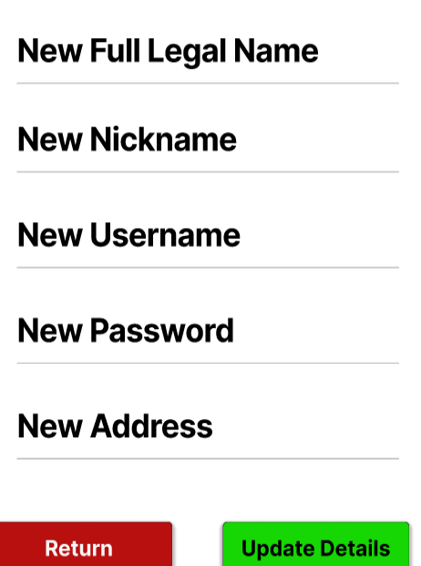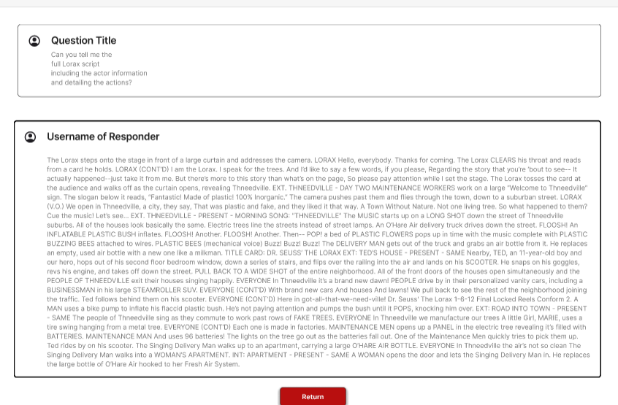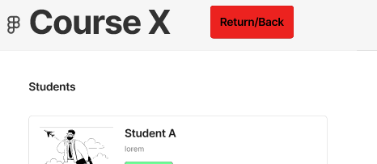

Here, I’ve some examples of where in my interface, there is a clear option to back out, by clicking red button, named, “return/back”, “return”, “go back” … This button allows for a clear emergency exit that the user can take.

Help and Documentation
My interface unfortunately doesn’t make it too clear where to find the help option, however, it does exist and isn’t too difficult to find. Rather, it’s put in a spot where it is most relevant. When a student wants to view their account and or manage information, they go to their account management page, where here, they can see the ’help’ option. This does follow the pert of the heuristic where there is an area for finding & searching for help, but it could have been placed in a better, more accessible spot. I could have improved it by added it either to the start or just having a button regardless of page, that allows the user to access the ‘help’ option.
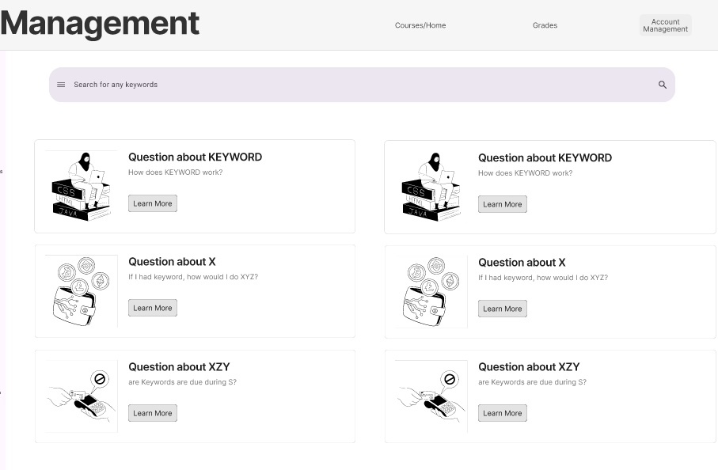

Aesthetics and Minimalist Design
For my design, I avoid including excessive amounts of information & items as I wanted a more spaced out, minimalist design and focus on the main requirements. For majority of interface, it follows this well as it only shows relevant information desired by the requirements.

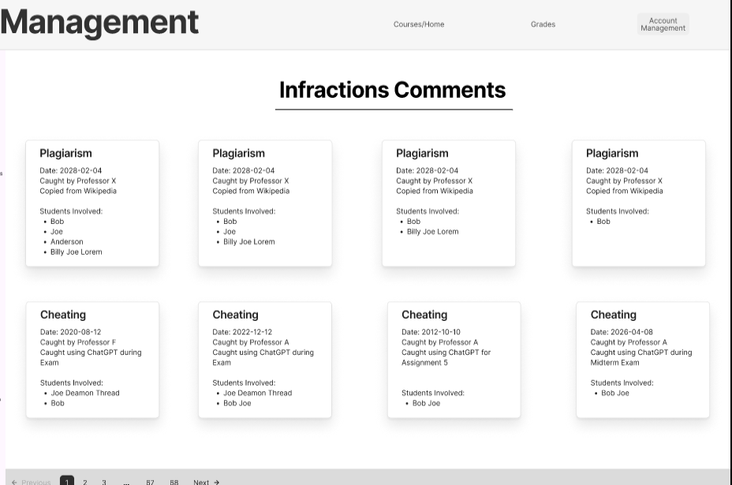

As you can see, this for instance, just shows the infractions the student has and nothing more. However, for some parts of my design, I do have more information than needed, for instance, in the documents tab, I have an extra part called “notifications”. This wasn’t required and does take away from the focus. To fix this, I should have centered the design more around the documents rather than extra content.

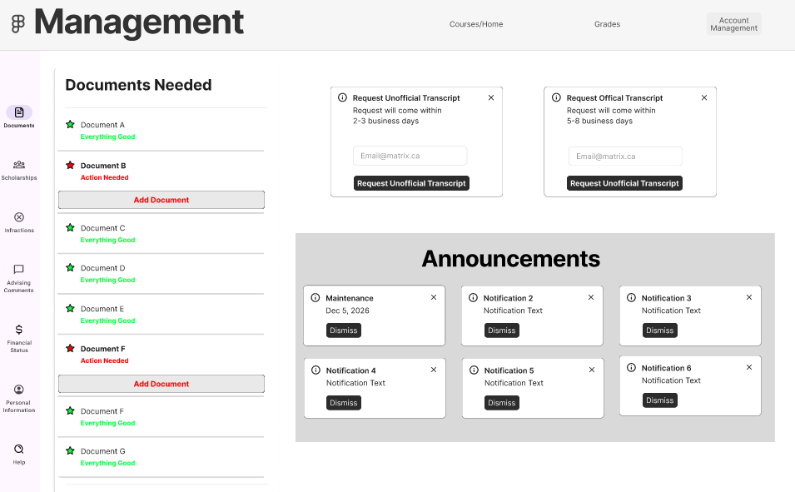

Recognition rather than Recall

I utilize widgets in my interface to help users clearly understand the meaning of a certain item without them needing to read it but rather, from them being able to simply just see the icon and understand. For example, the icons for the student account management, all have the icon and name, and the icon is a good representation of the associated names. I.e Documents is represented with a document, infractions is represented with an ‘x’, comments is done with a comment bubble …
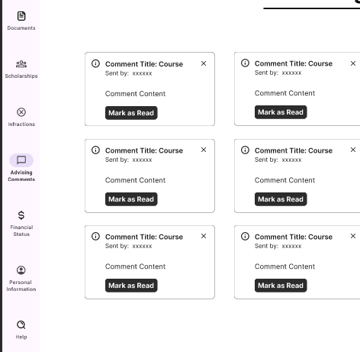

Error Preventions
So, in my video I cover how my interface would have built in error prevention. Where the buttons would be grayed out as needed, (i.e if the login info is a students, the faculty login button is grayed out and if hovered, gives the text, “account is a student account not faculty, please use the student login”), and of how, the inputs, would limit themselves and verify all the information is as needed when the user tries to submit. And, if they fail, the interface will highlight the problematic input with red and tell the user the issue.

Consistency and Standards
For my interface, all the symbols, colours, words and items all follow the standard and expectations of what they should be. When a user clicks any button, that button will only do as it is written, and all the language choice, i.e “More Details”, is clear, consistent, and standard in meaning. There is no double meaning in the selections as they all outline exactly what they mean and the symbols used, all match with standards.
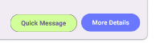

Match Between System and Real time World
All my conventions, match with real world thoughts, expectations and experiences. The back/return button is always labeled as the red button, which matches with the expectation as an emergency exit. As we associate red with exit, the back will always be the red button. Similarly, with good or success, we associate it with green, so not only is the submission buttons green but also, things like student grades are highlighted green is good. The colour of the grade indicates how good it is. With yellow/orangish indicating okay.
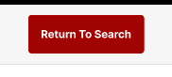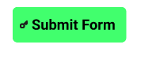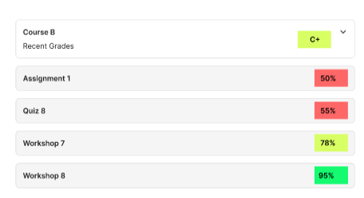
(continued on next page)
- Persona Walkthrough
  - Persona
  - Cognitive Walkthrough

Persona
Celestus Lorem - Professor/Faculty
- Age: 35
- Major: Computer Science
- Tech skills: Excellent
Overview:
Celestus is a 35-year-old professor who teaches computer science. He uses a multitude of technology to manage and keep track of students. As he teaches a multitude of students, he needs an easy and quick way to add grades, send messages, view a student's profile and see his schedule for the week. His main annoyances come from the time taken to find students, having to manually go to the search page and look-up his students over just being able to see it from the course page, manually having to enter students’ email' and not having a easy to find schedule.
Goals:
- Quick messaging
- Easy to find schedule
- easily add grades
- quick way to view a student's details
Frustrations:
- manually entering in the email address for a student
- manually having to go the search page to lookup a student
- having to actively search for his schedule
Motivation:
- relies on the system to provide an easy way to manage all his students as to not need to use a numerous amount of software’s
Behaviour Patterns:
- High-frequency user, he will be using the system a lot as he needs to manage and constantly deal with students
- Time-Conscious user, he values his time and expects tasks like grading, messaging and viewing to take minimal time. Avoids complex and lengthy workflows.

Cognitive Walkthrough
Step 1:
- Login using faculty credentials
  - The correct option is obvious as he knows he is a faculty member, so he will select the faculty login after entering his account information
  - The next step to click the login button would be understood as it is labeled with the word “login”, and it is standard to have the button referred as "login” to be pressed after entering the credentials
  - The information is required as the user cannot click the buttons without filling in their credentials first.
Step 2
- Look at their schedule
  - The correct option is obvious as one of the desires, wanting to see the schedule in a convenient spot is met as, it shows up after the faculty logs in
  - The next step of clicking on one of the courses that appear to the left of the schedule would be understood as above, it shows a radio button that has “Show enrolled courses” selected, this implies that the courses being shown are the owns they are teaching.
  - There is no information necessary to decide as there is no decision at this step but rather, there is one on the next
Step 3
- Select a course
  - The correct option is obvious as, not only does the faculty wish to view this course but also the cursor changes to a pointer one, indicating they are clickable. As the faculty wants to see the course and students within it, they would reasonably click the course.
  - The faculty would understand the next steps as he wants to either add a grade or view the student’s profile and both of those options are clearly labeled with buttons for the faculty to click
  - The information is necessary as it is needed to know which course he wants to specifically pick
Step 4
- Add a Grade
  - The correct option of clicking the “Add Grade” button is obvious as the button is separated for each student and is clearly labeled and defined as adding a grade
  - The next step of filling in the form is obvious as it is clear he wants to add a grade, so he just needs to fill out the respective information
  - The information is necessary for this step as he can pick to return to the previous page, add the grade or even just choose to view a student’s profile rather than adding a grade entirely
Step 5
- Clicking the Add Grade Button
  - The correct option is obvious as the “Add Grade” button clearly defines what it does, and he wants to add a grade, and it is clear what he needs to click to complete it, and it will send him back to the previous course page
  - He would understand the next step to perform as it would naturally lead him back to the previous page after adding a grade
  - No information is needed in this step other than knowing if he wants to add the grade or just cancel out
Step 6:
- Clicking the “View Details” for a specific student
  - The correct option is obvious as it is a button clearly labeled as “View Details” so when he wants to view the details of a student, he knows to click the button labeled it
  - He would understand the next step as he would already know what he’s looking for, so he would know what to look for on the student’s details page
  - The information needed is the student that he selects

